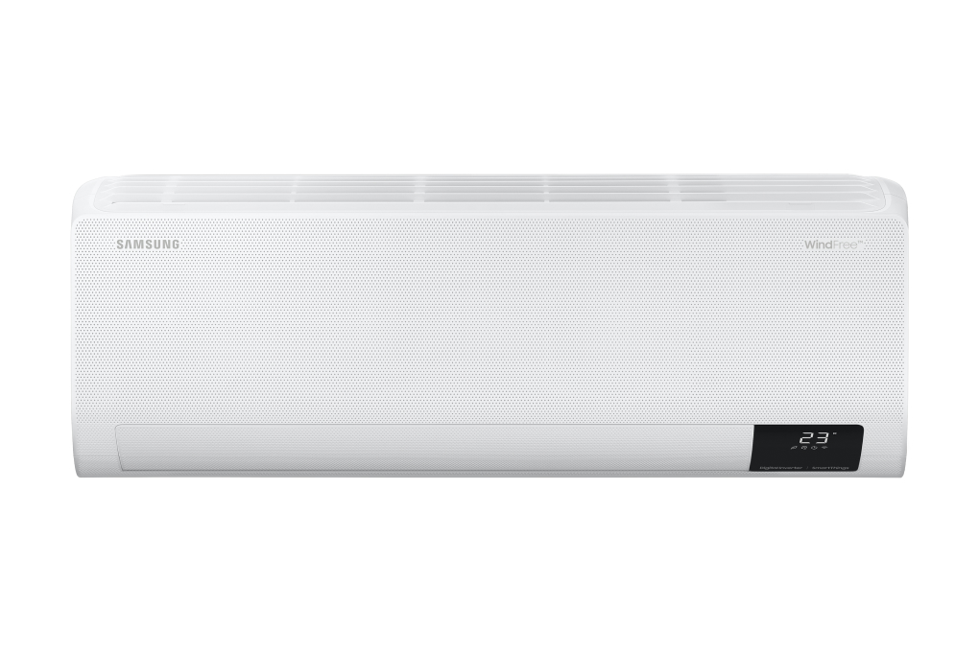

**14,490,000 VND**R IN ADVANCE - Delivery from 7 - 15 days

**Promotion worth 1,300,000 VND**

Prices and promotions are expected to apply until 11:00 p.m. | December 31

first

Choose 1 of the promotions:

- No copper pipes and supplies will be given away.  
- Delivery only, no installation.

**Technical specifications of Samsung Inverter air conditioner 1.5 HP AR13CYECAWKNSV**

* Machine Type:

1 way (cooling only) With Inverter

* Cooling capacity:

1.5 HP - 12,000 BTU

* Effective cooling range:

From 15 - 20m² (from 40 to 60 m³)

* Dust filter, antibacterial, deodorant:

4 in 1 filter

* Power saving technology:

Digital Inverter BoostEco

* Rapid cooling:

Fast Cooling

* Utilities:

Good Sleep mode Wind-Free mode for comfortable cold air Dehumidifying function Freeze Wash deep cleaning function Auto Clean self-cleaning function On-off timer Smart refrigerator AI Auto Cooling Display screen temperature on the indoor unit Automatically restarts when power is restored Remote control via SmartThings application

* Power consumption:

1.07 kW/h 5 stars (Energy efficiency 5.30)

* Cooler:

Length 88 cm - Height 37.5 cm - Thickness 29 cm - Weight 10.3 kg

* Outdoor:

Length 84.4 cm - Height 62.2 cm - Thickness 35.3 cm - Weight 24.1 kg

Introducing the company 

- A brand from Korea, founded in 1938.  
- Samsung is a multi-industry corporation, with a high level of brand recognition on a global scale.  
- Samsung's products range from mobile devices, home appliances, electronics,...  
- With the strength of being the brand of a global corporation, the quality of products always reaches the highest level of perfection. , good warranty should be trusted by customers around the world.

***Belonging to the Wind-Free air conditioner line,***[***the Samsung Inverter 1.5 HP AR13CYECAWKNSV air conditioner***](https://www.dienmayxanh.com/may-lanh/samsung-inverter-15-hp-ar13cyecawknsv)***possesses many technologies to cool the space and ensure the air is always clean thanks to many technologies such as 4 in 1 filter, Fast Cooling. , remote control via SmartThings application,...***

**Design overview**

**Cooler**

- The air conditioner has a familiar rectangular design with a neutral white background that easily combines with the interior of the building no matter where it is installed. A special feature of this product is that the mask has many tiny holes to support the cooling ability and is a highlight of the product.

- There is [a temperature display screen](https://www.dienmayxanh.com/may-lanh-man-hinh-hien-thi-nhiet-do-tren-dan-lanh) right on the indoor unit so you can easily identify the temperature in use without needing to find a remote.**Outdoor**

- The outdoor unit has a compact design with sturdy materials that can withstand impacts from the surrounding environment.

- **Copper gas pipes** help pump gas and absorb heat faster, so [the air conditioner](https://www.dienmayxanh.com/may-lanh) cools quickly. Combined with durable **aluminum heatsinks  , this ensures stable cooling performance.**

**Refrigeration technology**

- Operating with a capacity of 1.5 HP, this [Samsung air conditioner](https://www.dienmayxanh.com/may-lanh-samsung) is suitable for space areas from 15 - 20m².

- With [Fast Cooling mode](https://www.dienmayxanh.com/kinh-nghiem-hay/cac-cong-nghe-noi-bat-tren-may-lanh-samsung-1423437#fast-cooling) , the air conditioner will operate at high capacity to quickly bring the room to the correct set temperature. This function has the ability **to cool 43% faster**  than normal mode, saving waiting time, giving you an instant cool space.

- **Smart cooling AI Auto Cooling** will automatically analyze space conditions, environment and usage habits to optimize cooling capacity through modes. This creates a cool, comfortable and energy-saving space.

**Power saving technology**

- Equipped with **Digital Inverter Boost technology** , with an 8-pole compressor to help the air conditioner operate more stably and save more energy than conventional models. This technology also ensures good cooling ability, smooth operation and durability.

- In **Eco mode** , the air conditioner still ensures cooling temperature but operates at a lower capacity, thereby saving more energy when used.

**Air filtration technology**

- To further improve the ability to clean the air, Samsung has integrated a **4 in 1 filter** on this [Inverter air conditioner](https://www.dienmayxanh.com/may-lanh?g=may-lanh-inverter) to optimize the ability to filter coarse dust, fine dust and remove bacteria in the space, thanks to That brings cleaner and better quality air.

- **Freeze Wash deep cleaning function** works with the freezing mechanism of the evaporator to collect dirt and use wind to melt the ice, helping the evaporator become cleaner after each use, improving cooling capacity.

- **The Auto Clean self-cleaning function** will operate in 10 to 30 minutes with 3 steps to remove moisture on the indoor unit to help limit mold and bacteria growth.

**Air blowing mechanism**

- The cold air flow is spread evenly throughout the room thanks to the **automatic up, down, left and right control** mechanism , convenient and easy to use via remote.

- The highlight of this air conditioner is that it has [Wind-Free air blowing technology](https://www.dienmayxanh.com/kinh-nghiem-hay/wind-freecong-nghe-lam-lanh-cua-tuong-lai-1068729) , cooling by blowing air through 23,000 tiny holes right on the condenser cover. Thanks to that, the cold air blows out comfortably, quickly and does not cause numbness.

**Utilities**

-  [Good Sleep mode](https://www.dienmayxanh.com/may-lanh-che-do-ngu-dem-tranh-buot) will automatically increase the temperature after 2 hours of use, thereby preventing frostbite at night, helping you have a good night's sleep.

**- The dehumidifying function** will remove the amount of water in the space to create a more comfortable environment, especially on rainy days.

-  [Remote control via SmartThings application](https://www.dienmayxanh.com/may-lanh-co-wifi-chinh-bang-dien-thoai) allows users to monitor, check and adjust the mode and temperature of the air conditioner anywhere with a smartphone.

- **On-off timer** allows users to proactively set convenient time to turn on and off the air conditioner.

- When an electrical problem occurs, the air conditioner can **automatically restart when there is power** .

*Overall, the Samsung Inverter 1.5 HP AR13CYECAWKNSV air conditioner is a modern product that fully meets the requirements of a high-end air conditioner such as cooling, saving electricity, air filtration and can be controlled with modern wifi.*